EEE3099S Project Team 10

**WeMove** **Team**

|  |  |
| --- | --- |
| *Cameron Clark* | *CLRCAM007* |
| *Kian Frassek* | *FRSKIA001* |
| *Thiyashan Pillay* | *PLLTHI032* |

Table of Contents

1. Table listing individual contributions 3

2. Introduction 4

3. Requirement Analysis 5

3.1. Functional Requirements 5

3.2. Constraints 5

3.3. Possible Bottlenecks 5

4. Sub System Design 6

4.1. Subsystem and Sub-subsystems Requirements 6

4.2. Subsystem and Sub-subsystems Specifications 6

4.3. Inter-subsystems Interactions 7

4.4. UML Diagrams were possible 8

5. Acceptance Test Procedure 9

5.1. Figures of merits based on which you would validate your final design. 9

5.2. Experiment design to test these figures of merit. 9

5.3. Acceptable performance definition 10

6. Development Timeline 11

7. Circuit Design 12

8. References 14

9. Appendix 1: Cameron Clark MATLAB Certificates 15

10. Appendix 2: Kian Frassek MATLAB Certificates 17

11. Appendix 3: Thiyashan Pillay MATLAB Certificates 19

12. Appendix 4: Weekly reviews 21

# Table listing individual contributions

|  |  |
| --- | --- |
| **contributions for we move** | |
| **who did it** | **Contributed** |
| **Milestone 1** | |
| Kian | Introduction & Req. Analysis |
| Cameron | Subsystem Design |
| Thiyashan | ATP |
| Kian, Thiyashan | Timeline and PM Page |
| all | Onramp courses |
| Thiyashan | weekly review |
| Kian, Thiyashan | block diagram |
| Cameron | references |

# Introduction

A line follower robot is a common robotic task where a robot with a simple drive system, sensors and a microcontroller is tasked to follow a line and sometimes complete tasked along the way. In this iteration of a line follower robot design challenge, there is a treasure hunt taking place. The goal is for the robot to take a twisting path with intersections and dead-ends, stopping at all the specified measurement lines to measure the distance to the treasure objects using an ultrasonic sensor, and finally stopping at a specified black rectangle.

The provided equipment includes the chassis (the structure, wheels, motors and motor drivers), the sensors (five line sensors, two motor rotation sensors, one ultrasonic sensor), the batteries (with power switches) and finally the microcontroller. Our goal is to regulate the two 18650 batteries to a stable 5V to power the onboard equipment as well as the coding the brain of the operation: the Arduino Nano.

This document is an in depth analysis of the requirements, the sub-system design, an acceptance test procedure, and an expected development timeline.

# Requirement Analysis

## Functional Requirements

|  |  |
| --- | --- |
| Basic Modular Requirements | * Powering on. * Movement capability. * Functioning line sensors capable of line detection. * The ability to measure the distanced using ultrasonic sensor. * Battery reverse polarity protections * Battery undervoltage lockout * Power current limiting |
| Intermodular Interfacing Requirements | * Individual motor control through the H-Bridge using * Receiving data from line sensors * Triggering and receiving data from ultrasonic sensor |
| Complex Microcontroller Requirements | * Recording, storing, and analysing routes and intersection traversed by the robot. * Implementing specific criteria for stopping at certain points during navigation. * Deciding when to measure distances to objects based on predetermined conditions. * Precise control over the direction and speed of the robot. * Efficient path planning. * Safety features. |

## Constraints

1. Voltage supply and logic level: 5V.
2. Veroboard size: 100mm x 50mm; no breadboard allowed.
3. Power source: Operates off 2 x 18650 3.7V Batteries connected in series, regulated to 5.0V
4. Sensor placement: An ultrasonic sensor positioned at the front of the robot.
5. Line sensors: A maximum of 5-line sensors to be utilized.
6. Components: The usage of specific components is specified.
7. Time constraints: Project completion within a specified timeframe.
8. Availability of parts: Consideration of component availability during the project.
9. Mechanical specifications: Determining axle length and wheel diameter for the robot's movement.

## Possible Bottlenecks

1. Processing and sensor speed: Ensuring that the microcontroller or processing unit can handle the required computations efficiently and that the sensor response time is suitable for real-time decision-making.
2. Battery power: Optimizing power usage to ensure extended operation time and implementing mechanisms for battery charging or replacement when required.
3. High turning speed stability: Designing the robot's mechanical and control systems to maintain stability and prevent issues like tipping or skidding during high-speed turns.
4. Subsystem Design: Developing and integrating different subsystems, such as motion control, sensor interfacing, data storage, and decision-making, to work harmoniously and achieve the project objectives.

# Sub System Design

## Subsystem and Sub-subsystems Requirements

|  |  |
| --- | --- |
| Power: | * Regulate the power supply to 5V to meet the system requirements. * Ensure sufficient current capacity to power all subsystems. ww * Implement Under Voltage Lockout (UVLO) and Reverse Polarity (RP) protection mechanisms. * Monitor and regulate current usage. * Employ a current regulator to prevent the Low Voltage Regulator (LVR) from malfunctioning. |
| Microcontroller: | * Process sensor data in real-time and efficiently interpret it. * Output processed data to drive systems and control the logic flow of the robot. * Perform data processing at a faster rate than the sensor data acquisition. * Incorporate an LED indicator to signify the operation of the ultrasonic sensor. |
| Motor drive and Motors: | * Enable forward, reverse, and turning controls for smooth navigation. * Ensure speed control of the motors for precise movement. |
| Mechanical: | * Chassis is already built to house all components. * Build should be able to sustain knocks in the case of failure. |
| Sensors: | * Utilize fast and accurate line sensors to provide real-time data on the robot's position. * Ensure the ultrasonic sensor delivers quick and precise distance measurements for effective obstacle detection. |

## Subsystem and Sub-subsystems Specifications

|  |  |
| --- | --- |
| Power: | * Regulate the power supply to 5V, accepting input voltages between 6V and 8.4V. * Ensure sufficient current capacity to power all subsystems at 5A. * Implement Under Voltage Lockout (UVLO) at 6V to protect the system from undervoltage conditions. * Use a Reverse Polarity (RP) protection circuit consuming less than 1mW. |
| Microcontroller: | * Receive 5V power supply and convert the 3V3 logic level outputs to 5V using a Logic Level Converter. * Optimize calculations between the line sensors and H-Bridge output to be completed in less than 1ms. |
| Motor drive and Motors: | * Ensure the motors can rotate at a constant speed. * Power the motors with a 5V supply and ensure the system can handle up to 5A current. |
| Mechanical: | * Utilize a Veroboard with dimensions of 100mm x 50mm. |
| Sensors: | * Implement data transmission within less than 10 clock cycles to achieve high sensor speed. |

## Inter-subsystems Interactions

|  |  |
| --- | --- |
| Power: | * Supplies regulated 5V power to all subsystems. * Includes protection mechanisms like UVLO and RP for safety. * Ensures sufficient current capacity for all components. |
| Microcontroller: | * Receives 5V power and uses a Logic Level Converter to convert 3V3 logic to 5V for interfacing with other subsystems. * Interprets sensor data and performs calculations for speed and turning control. * Communicates with the motor drive, line sensors, ultrasonic sensor, and other components. |
| Motor drive and Motors: | * Receives 5V power from the microcontroller. * Enables precise control over the motors for forward, reverse, and turning motions. * Ensures motors rotate at a constant speed for stable movement. |
| Mechanical: | * Hosts all components. * Provides protection and robustness to internal components. |
| Sensors: | * Delivers fast and accurate data from the line and ultrasonic sensors. * Transmits data to the microcontroller within short intervals. |

## UML Diagrams were possible

# Acceptance Test Procedure

## Figures of merits based on which you would validate your final design.

|  |  |
| --- | --- |
| Power On | Verification that the robot powers on and initializes successfully. |
| Interconnectivity | Ensuring that all subsystems and components communicate effectively with each other. |
| Movement | Validating that the robot can move autonomously as intended. |
| Speed and turning control | Verifying precise control over speed and turning during navigation. |
| Line following | Confirming that the robot can accurately follow a line on the designated path. |
| Intersection resolution | Ensuring that the robot can correctly resolve intersections and continue its path accordingly. |
| Path mapping | Validation of the robot's ability to map paths and keep track of the routes taken during navigation. |
| Stop and measure distances | Verifying that the robot can halt at specific measuring points and accurately measure distances to objects. |
| Termination | Confirmation that the robot terminates its movement when it reaches the designated stop point or the end of the maze. |

## Experiment design to test these figures of merit.

|  |  |
| --- | --- |
| Check Power System and LEDs | * Ensure all power connections are secure and within the specified voltage range. * Verify that the LEDs used for indicators (e.g., power on, ultrasonic sensor running) function correctly. |
| Check Microcontroller Communication with Components | * Test communication between the microcontroller and all subsystems/components to confirm interconnectivity. |
| Test Basic Movement | * Input a simple move command to the microcontroller and verify if the robot moves accordingly. |
| Test Advanced Movement | * Input specific move commands with varying speed and turning parameters to validate precise control over movement. |
| Line Following Test | * Run the robot on this path to ensure it accurately follows the line. |
| Intersection Resolution Test | * Verify that the robot correctly chooses and traverses each possible path at the intersection. |
| Path Mapping Test | * Allow the robot to navigate a complex maze while recording its path. * Analyse the recorded data to ensure the robot successfully maps the paths it took. |
| Stop and Measure Distance Test | * Incorporate a measuring point with an object placed at a specific distance. * Verify that the robot halts at the measuring point and accurately measures the distance to the object. |
| Termination test | * Set a designated stop point or end of the maze. * Confirm that the robot terminates its movement upon reaching the stop point. |

## Acceptable performance definition

|  |  |
| --- | --- |
| Power On | The robot must consistently power on and initialize its systems without any failures. |
| Interconnectivity | All subsystems and components should establish and maintain reliable communication to ensure seamless operation. |
| Movement | The robot should be able to move smoothly and consistently, responding appropriately to navigation commands. |
| Speed and turning control | The robot should exhibit precise speed control and turning capabilities for accurate manoeuvring. |
| Line following | The robot should accurately follow the designated line path, keeping within acceptable deviations. |
| Intersection resolution | The robot must correctly identify and traverse all possible paths at intersections. |
| Path mapping | The robot's path mapping should be accurate, capturing the routes taken during navigation effectively. |
| Stop and measure distances | The robot should halt precisely at measuring points, and its distance measurement to objects should have acceptable accuracy. |
| Termination | The robot should terminate movement upon reaching the designated stop point or the end of the maze consistently. |

# Development Timeline



# Circuit Design

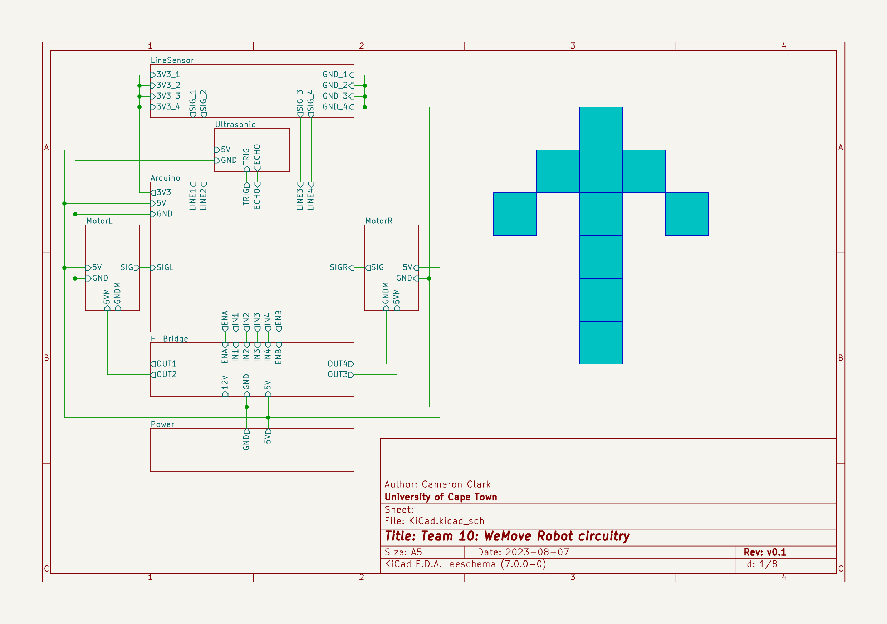

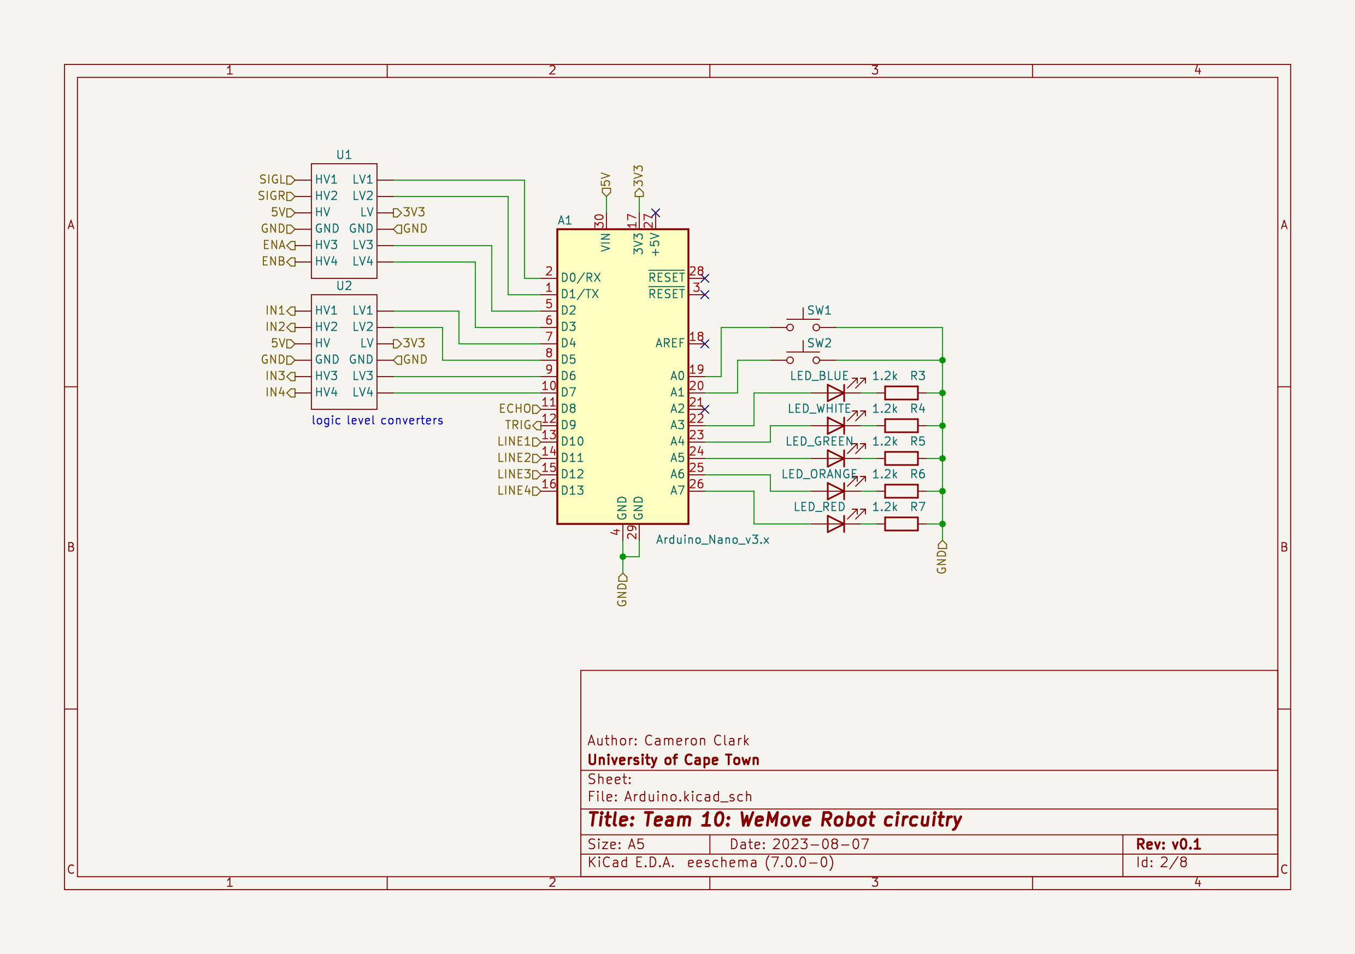

# References

MATLAB. (2023, August 2023). *MATLAB*. Retrieved from Self-paced courses: https://matlabacademy.mathworks.com/

University of Cape Town. (2023, August 10). *Amathuba*. Retrieved from Amathuba: https://amathuba.uct.ac.za/d2l/le/lessons/14473/lessons/1236527

# Appendix 1: Cameron Clark MATLAB Certificates





# Appendix 2: Kian Frassek MATLAB Certificates

 

 

# Appendix 3: Thiyashan Pillay MATLAB Certificates



 

# Appendix 4: Weekly reviews

**Week Ending**

04 August 2023

**Group Members:**

|  |  |
| --- | --- |
| **Student Name** | **Student Number** |
| Cameron Clark | CLRCAM007 |
| Kian Frassek | FRSKIA001 |
| Thiyashan Pillay | PLLTHI032 |

**Project Status**

**Accomplishments:**

* Started with the paper design, outlining the requirement analysis, subsystem design, acceptance test procedure and development timeline.
* Set up an excel spreadsheet used to document our individual contributions.
* Created a repository for our project.
* Create an image of the circuit design on KiCAD.
* Made block diagram.
* Finished the microcontroller diagram

**Issues**

So far, no issues have arisen.

**Upcoming Tasks**

Provide a list of tasks that are planned for the next week.

* Finalize the report details.
* Fill in the work breakdown.
* Power circuit diagram.

**Attachments**

NA.

**Signatures**

|  |  |  |
| --- | --- | --- |
| Cameron Clark | Kian Frassek | Thiyashan Pillay |
|  |  |  |

**Week Ending**

11 August 2023

**Group Members:**

|  |  |
| --- | --- |
| **Student Name** | **Student Number** |
| Cameron Clark | CLRCAM007 |
| Kian Frassek | FRSKIA001 |
| Thiyashan Pillay | PLLTHI032 |

**Project Status**

**Accomplishments:**

* Filled in the work breakdown (Timeline).
* Designed the power circuit diagram.
* Finalized some of the report details.
* Start designing the power circuitry.
* Finished building a prototype power circuit on the breadboard.

**Issues**

So far, no issues have arisen.

**Upcoming Tasks**

Provide a list of tasks that are planned for the next week.

* Complete all MATLAB courses and save the certificates in the repository.
* Hand in milestone 1.
* Start with MATLAB simulations.

**Attachments**

NA.

**Signatures**

|  |  |  |
| --- | --- | --- |
| Cameron Clark | Kian Frassek | Thiyashan Pillay |
|  |  |  |

**Week Ending**

18 August 2023

**Group Members:**

|  |  |
| --- | --- |
| **Student Name** | **Student Number** |
| Cameron Clark | CLRCAM007 |
| Kian Frassek | FRSKIA001 |
| Thiyashan Pillay | PLLTHI032 |

**Project Status**

**Accomplishments:**

* Finalize the submission for milestone 1.
* Finish MATLAB courses.
* Discussed final questions with a tutor.

**Issues**

So far, no issues have arisen.

**Upcoming Tasks**

Provide a list of tasks that are planned for the next week.

* Start with milestone 2.

**Attachments**

NA.

**Signatures**

|  |  |  |
| --- | --- | --- |
| Cameron Clark | Kian Frassek | Thiyashan Pillay |
|  |  |  |